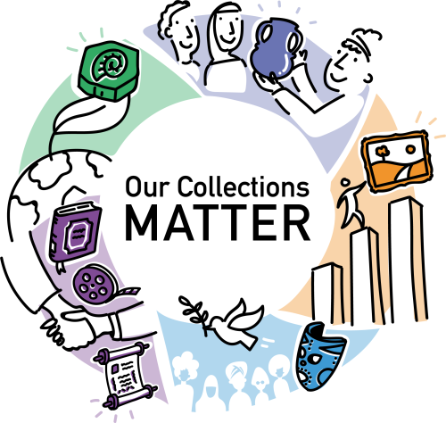
CASE STUDY SUBMISSION FORM

First name
Last name
Country
Organization you work for
Work email address
Title of case study | (Write as a short sentence, outlining how it contributes to sustainable development, e.g., New Conservation Approach Helps Community Library Support Adult Literacy More Effectively)
Name of project/initiative | (Title of project, if there is one)
The context of the activity | (Up to 50 words: help readers understand the context that your organization works in: the place, community, sustainable development aspirations or challenges, situation, etc. beyond the organization, to help them understand why what you did was worth doing)
Description of activity | (Up to 150 words: your main opportunity to explain to readers what you did: why was it important/relevant/what aspiration or challenge did it address, where and when did it happen, who took part, how was it different, how did conservation play an essential part? Include statistics if possible, e.g., numbers of participants, demographics.)
How it contributed to sustainable development | (Which of the 17 Sustainable Development Goals was the activity related to/did it help achieve. Choose up to 3 SDGs, no more, and try not to just choose SDGs 4 (education) and 11 (which includes heritage).  SDG 1: End poverty in all its forms everywhere  SDG 2: End hunger, achieve food security and improved nutrition and promote sustainable agriculture  SDG 3: Ensure healthy lives and promote well-being for all at all ages  SDG 4: Ensure inclusive and equitable quality education and promote lifelong learning opportunities for all  SDG 5: Achieve gender equality and empower all women and girls  SDG 6: Ensure availability and sustainable management of water and sanitation for all  SDG 7: Ensure access to affordable, reliable, sustainable and modern energy for all  SDG 8: Promote sustained, inclusive and sustainable economic growth, full and productive employment and decent work for all  SDG 9: Build resilient infrastructure, promote inclusive and sustainable industrialization and foster innovation  SDG 10: Reduce inequality within and among countries  SDG 11: Make cities and human settlements inclusive, safe, resilient and sustainable  SDG 12: Ensure sustainable consumption and production patterns  SDG 13: Take urgent action to combat climate change and its impacts  SDG 14: Conserve and sustainably use the oceans, seas and marine resources for sustainable development  SDG 15: Protect, restore and promote sustainable use of terrestrial ecosystems, sustainably manage forests, combat desertification, and halt and reverse land degradation and halt biodiversity loss  SDG 16: Promote peaceful and inclusive societies for sustainable development, provide access to justice for all and build effective, accountable and inclusive institutions at all levels  SDG 17: Strengthen the means of implementation and revitalise the global partnership for sustainable development)
Measures of success/difference/impact | (Up to 150 words. This section is your main opportunity to explain to readers what difference the activity made and how it contributed to sustainable development. Include numbers/quantitative information, or qualitative information. Demonstrate the difference made, if possible, through results, data, comments from others.  Keep in mind that this is the most important part of the case study, and the focus is the difference made for society, the environment or economy beyond the organization.  What has changed? Has it been about a change in knowledge, attitudes or skills, or has it been about cross-sector working?  Remember to highlight how conservation contributed to this impact.)
Images | (Please provide 2-3 images, preferably landscape, high resolution (300 dpi).  The images should illustrate as clearly as possible your case study, highlighting how the conservation of heritage collections can contribute to support one or more sustainable development goals.  Please provide the images as separate attachments to your email when submitting this form, paying attention to the total file size of the attachments. If the attachments are too large your email might not be delivered. In this case, please try to split it into multiple messages or use dedicated platforms to send large files, such as WeTransfer.  We would like your pictures with a Creative Commons Attribution-NonCommercial-ShareAlike 4.0 International (CC BY-NC-SA 4.0): https://creativecommons.org/licenses/by-nc-sa/4.0/, which means that you give permission to share and adapt your pictures for non-commercial purposes and that they must be given appropriate credit. In case of adaptation, they must be distributed under the same license as the original.  You may provide images with a copyright (provided you are in a position to make use of those images); ICCROM does not take responsibility for how others make use of images under such conditions.)
Further information about the project online | (Web address 1)
 | (Web address 2)
 | (Web address 3)
Link to any videos online about the project | (Web address 1)
 | (Web address 2)
 | (Web address 3)

☐ I grant and authorize ICCROM to include information and materials of my case-study in the self-paced course and web page of the ‘Our Collections Matter’ initiative. This authorization shall continue indefinitely, unless I otherwise revoke this authorization in writing. I agree to this release without being compensated.
I also declare to have read in full and understood ICCROM Privacy Policy, including the specific purposes and legal bases of data processing stated therein. For any questions or clarifications, or if you wish to exercise your rights of access, rectification, erasure, process limitation, portability or objection, please do not hesitate to contact us at the following e-mail address: data-protection@iccrom.org.

