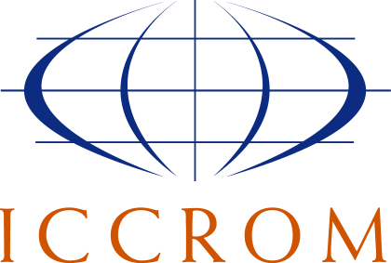
Making Our Collections Matter More
Field projects and capacity development - 2023

Application form
1. APPLICANT INFORMATION
Full name: Click here to enter text.
Nationality: Click here to enter text.
Phone (+ area code): Click here to enter text.
E-mail: Click here to enter text.
Present occupation: Click here to enter text.
Type of collections-based institution you work for: Choose an item.
Institution name: Click here to enter text.
Address: Click here to enter text.
Country: Click here to enter text.
Website: Click here to enter text.

2. COLLECTIONS & SUSTAINABILITY-RELATED INFORMATION
Describe the types of collections you work with:
Click here to enter text.

Describe what social, environmental and/or economic challenges or aspirations your institution wants to address through collections-based work:
Click here to enter text.

Have you been working with the Sustainable Development Goals (SDGs)? Choose an item.

In 100 words or less, tell us why you want to take part in this programme:
Click here to enter text.

3. OFFICIAL ENDORSEMENT
The undersigned [Name of director institution]
Name of institution: Click here to enter text.
Address: Click here to enter text.
Phone: Click here to enter text.
E-mail: Click here to enter text.
endorses the application of [Applicant name]
This endorsement implies that the institution will support the applicant in undertaking sustainable development-related activities with/around its collections using ICCROM’s Our Collections Matter Toolkit, as well as her/his participation in the bi-monthly online workshops in the course of 2023, as indicated in the call for participation.

Signature:
Date: Click or tap to enter a date.

☐ I give consent to the processing of my personal data by ICCROM for candidate selection purposes, including the sharing of profiles with partners and for reviewing and evaluating. Data will be also processed to promote new courses, internships, fellowships, programmes, initiatives, projects, events, round tables or other institutional activities or reports of ICCROM and/or its partners. Users can, at any time, request the erasure of their data at the following e-mail: data-protection@iccrom.org. I also declare to have read in full and understood ICCROM Privacy Policy, including the specific purposes and legal bases of data processing stated therein.

